UoC-CRGS-FRM-010; Rev 00



C E N T RE F O R R E S E A R C H A N D G R A D U A T E S T U D I E S

THESIS EXAMINER'S REPORT

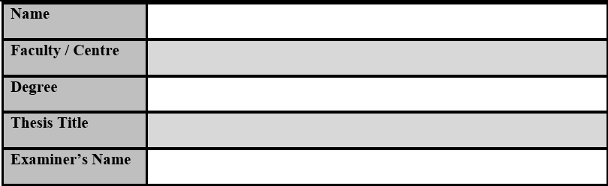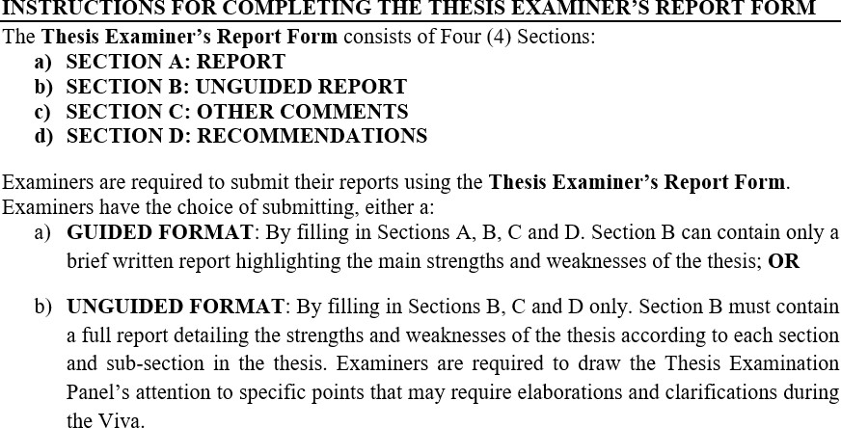

UoC-CRGS-FRM-010; Rev 00

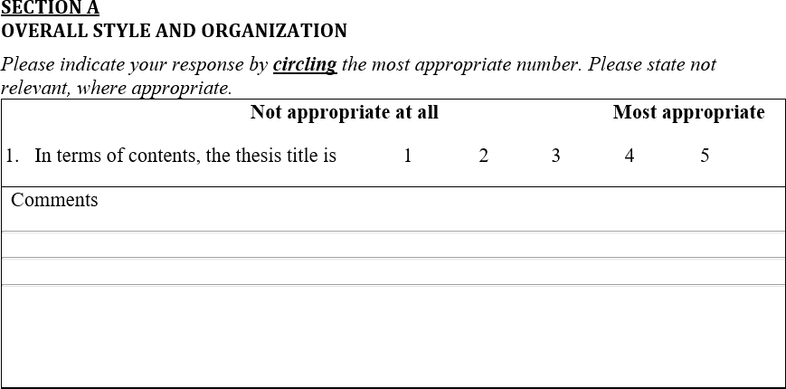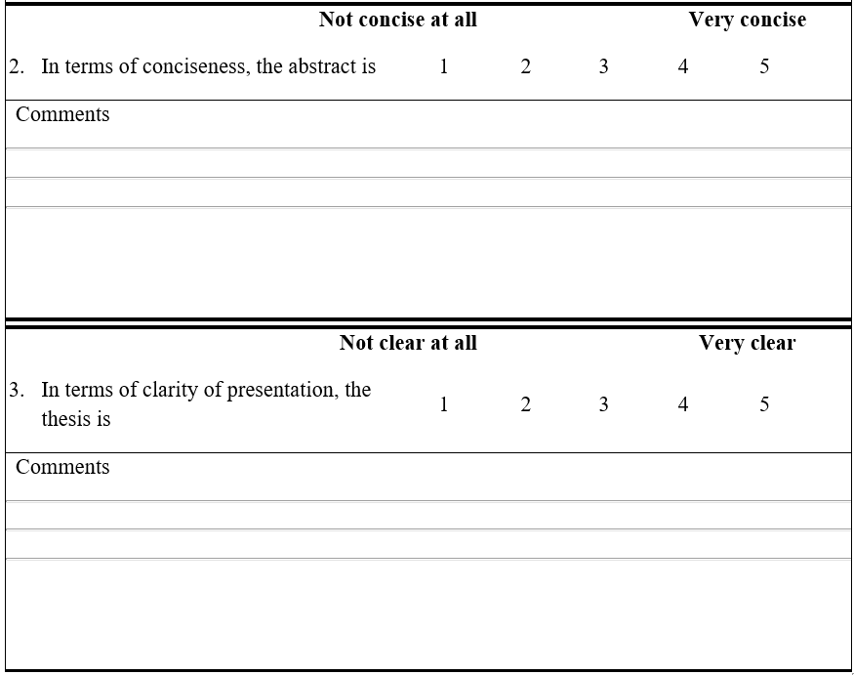

UoC-CRGS-FRM-010; Rev 00

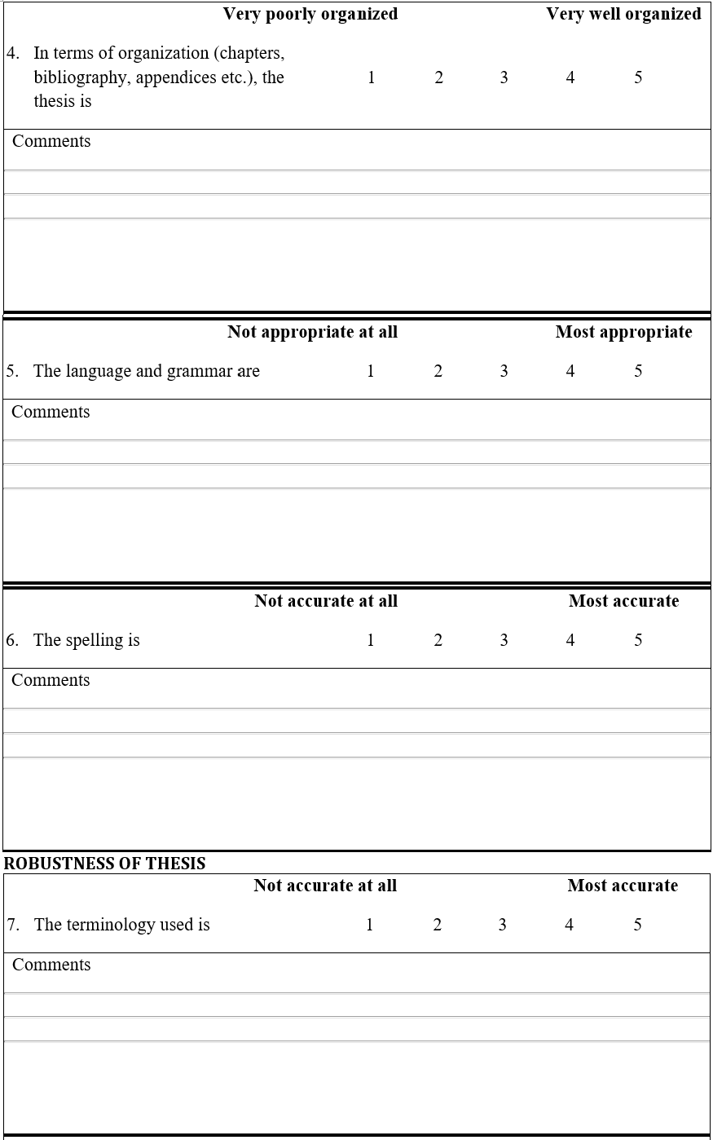

UoC-CRGS-FRM-010; Rev 00

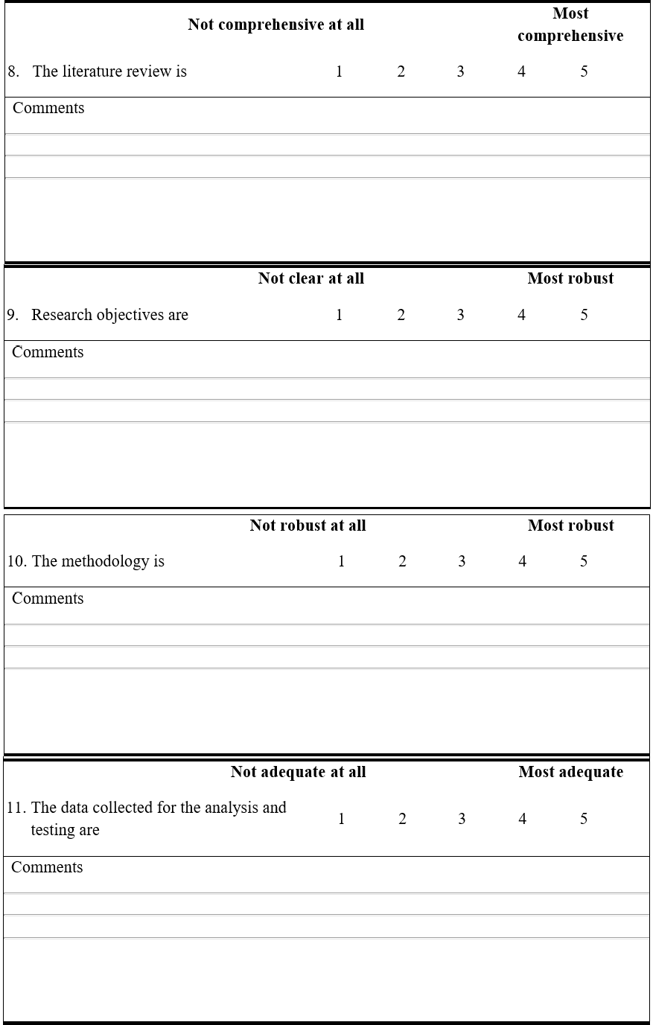

UoC-CRGS-FRM-010; Rev 00

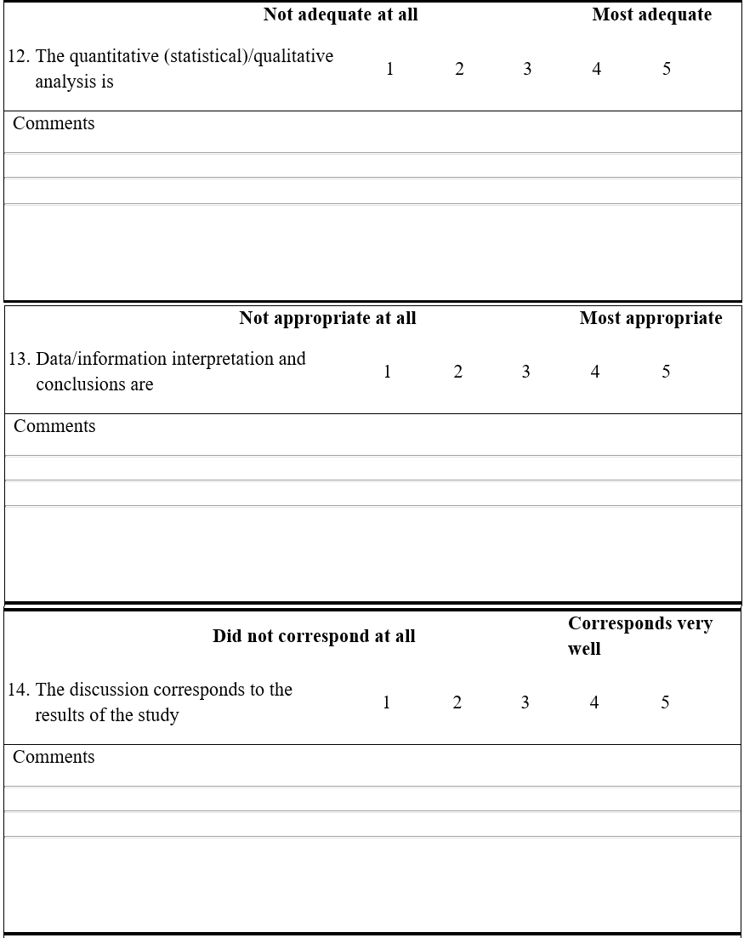

UoC-CRGS-FRM-010; Rev 00

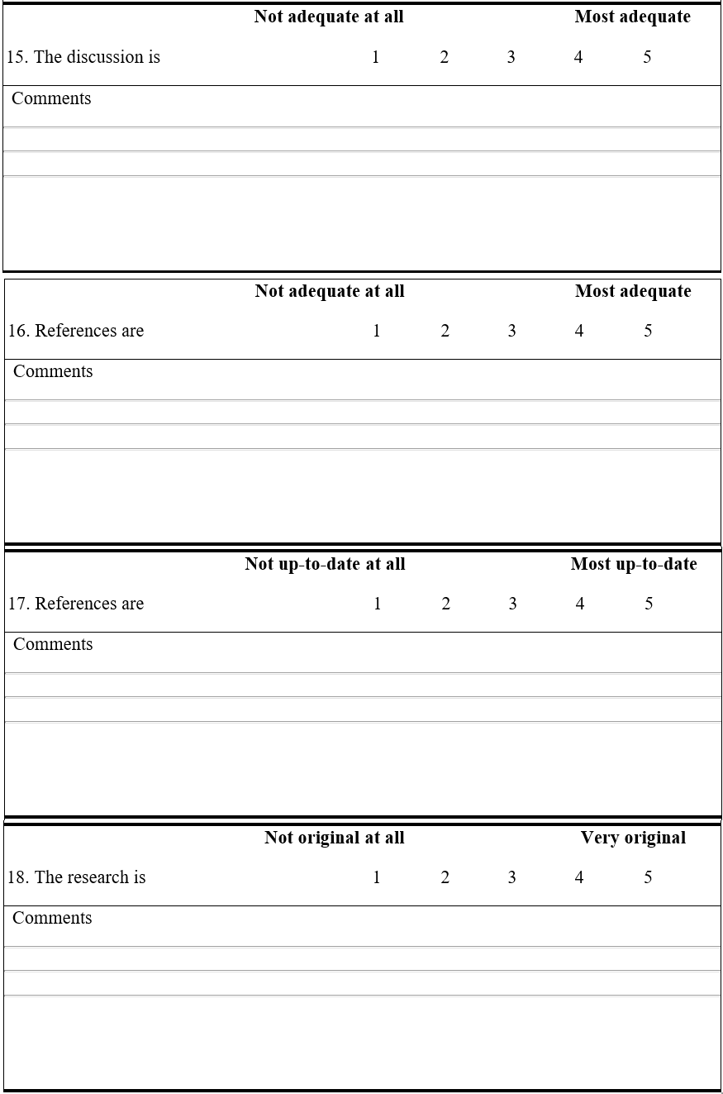

UoC-CRGS-FRM-010; Rev 00



UoC-CRGS-FRM-010; Rev 00





